June 27-29: Monday to Wednesday
School’s Out!

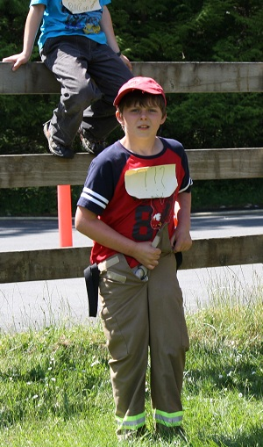
Final Edition!
This will be our final edition of the Saturna Elementary News for this year. Thank you to the Parent Advisory Committee for many field trips, our new digital camera and all your support this year.
A big thank you to the Saturna Parks and Rec, Saturna Lions Club, Sarah Henry and the Strong Start students, Al Stonehouse, The Saturna General Store for hosting our bottle drives, the Saturna Recycling center for donations of bottles and all of the community of Saturna Island for your generous support to the school.
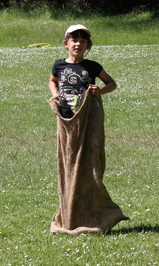
School will be held for Monday, Tuesday and Wednesday only next week. On Wednesday school will begin at 8:30 am as usual. We will have our picnic at Melanie Gaines on Wednesday, June 29 from 10-12. Our end of year celebration will begin at 1:00 and will last until about 2:30. Then.... it is school’s out for the students.
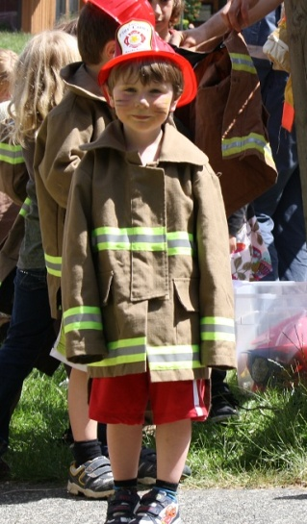
Truman and I have had a wonderful year at Saturna School. Thanks especially to the amazing students. We will never forget our time here.
